DAY-3

K.Raghavendra

192110345

1. Write a High level code for one-time pad version of the Vigenère cipher. In this

scheme, the key is a stream of random numbers between 0 and 26. For example, if the

key is 3 19 5 . . . , then the first letter of plaintext is encrypted with a shift of 3 letters,

the second with a shift of 19 letters, the third with a shift of 5 letters, and so on.

a. Encrypt the plaintext send more money with the key stream 9 0 1 7 23 15 21 14 11

11 2 8 9

b. Using the ciphertext produced in part (a), find a key so that the cipher text

decrypts to the plaintext cash not needed.

Code:

#include <iostream>

#include <string>

#include <vector>

std::string vigenere_encrypt(const std::string& plaintext, const std::vector<int>& key) {

std::string ciphertext = plaintext;

for (size_t i = 0; i < plaintext.length(); i++) {

if (isalpha(plaintext[i])) {

int shift = key[i % key.size()];

char base = (islower(plaintext[i])) ? 'a' : 'A';

ciphertext[i] = (plaintext[i] - base + shift) % 26 + base;

}

}

return ciphertext;

}

std::string vigenere_decrypt(const std::string& ciphertext, const std::vector<int>& key) {

std::string plaintext = ciphertext;

for (size_t i = 0; i < ciphertext.length(); i++) {

if (isalpha(ciphertext[i])) {

int shift = key[i % key.size()];

char base = (islower(ciphertext[i])) ? 'a' : 'A';

plaintext[i] = (ciphertext[i] - base - shift + 26) % 26 + base;

}

}

return plaintext;

}

int main() {

std::string plaintext;

std::vector<int> key;

std::cout << "Enter plaintext: ";

std::cin >> plaintext;

std::cout << "Enter key (space-separated integers): ";

int key_val;

while (std::cin >> key_val) {

key.push_back(key_val);

}

std::string ciphertext = vigenere_encrypt(plaintext, key);

std::cout << "Part (a) - Encrypted Text: " << ciphertext << std::endl;

// Part b - Decrypt the ciphertext

std::string decrypted_text = vigenere_decrypt(ciphertext, key);

std::cout << "Part (b) - Decrypted Text: " << decrypted_text << std::endl;

return 0;

}

Output:

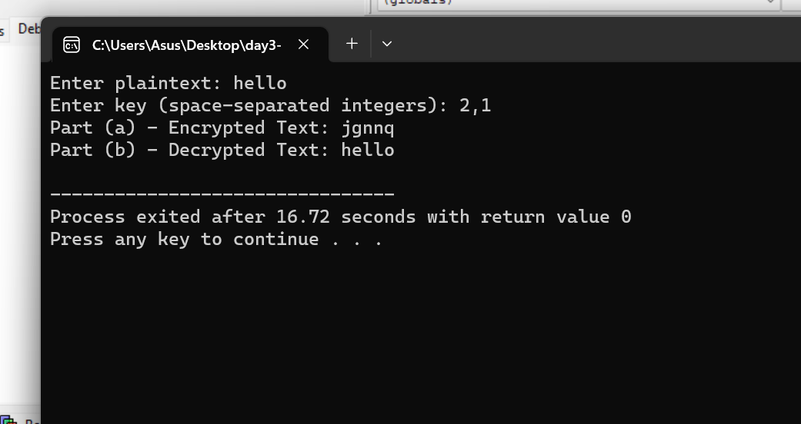

1. Write a High level code that can perform a letter frequency attack on an additive cipher without human intervention. Your software should produce possible plaintexts in rough order of likelihood. It would be good if your user interface allowed the user to specify “give me the top 10 possible plaintexts.”

Code:

#include <stdio.h>

#include <string.h>

#include <ctype.h>

#include <stdlib.h>

const char* ciphertext = "L qljsl rdltj!";

const double english_frequencies[] = {

0.0817, 0.0149, 0.0271, 0.0432, 0.1202, 0.0230, 0.0203, 0.0597,

0.0675, 0.0015, 0.0077, 0.0403, 0.0241, 0.0675, 0.0751, 0.0193,

0.0009, 0.0599, 0.0633, 0.0906, 0.0276, 0.0098, 0.0236, 0.0015,

0.0197, 0.0007

};

double compute_score(const char* text) {

double frequencies[26] = {0.0};

int total_letters = 0;

for (int i = 0; text[i]; i++) {

if (isalpha(text[i])) {

char c = tolower(text[i]);

frequencies[c - 'a'] += 1.0;

total_letters++;

}

}

for (int i = 0; i < 26; i++) {

frequencies[i] /= total_letters;

}

double score = 0.0;

for (int i = 0; i < 26; i++) {

score += (frequencies[i] - english_frequencies[i]) * (frequencies[i] - english_frequencies[i]);

}

return score;

}

// Function to decrypt the ciphertext using a key

void decrypt(int key) {

char plaintext[100];

int len = strlen(ciphertext);

for (int i = 0; i < len; i++) {

if (isalpha(ciphertext[i])) {

char base = isupper(ciphertext[i]) ? 'A' : 'a';

plaintext[i] = (ciphertext[i] - base - key + 26) % 26 + base;

} else {

plaintext[i] = ciphertext[i];

}

}

plaintext[len] = '\0';

double score = compute_score(plaintext);

printf("Key: %d, Score: %lf, Plaintext: %s\n", key, score, plaintext);

}

int main() {

printf("Ciphertext: %s\n", ciphertext);

printf("Possible plaintexts:\n");

for (int key = 0; key < 26; key++) {

decrypt(key);

}

return 0;

}

Output:

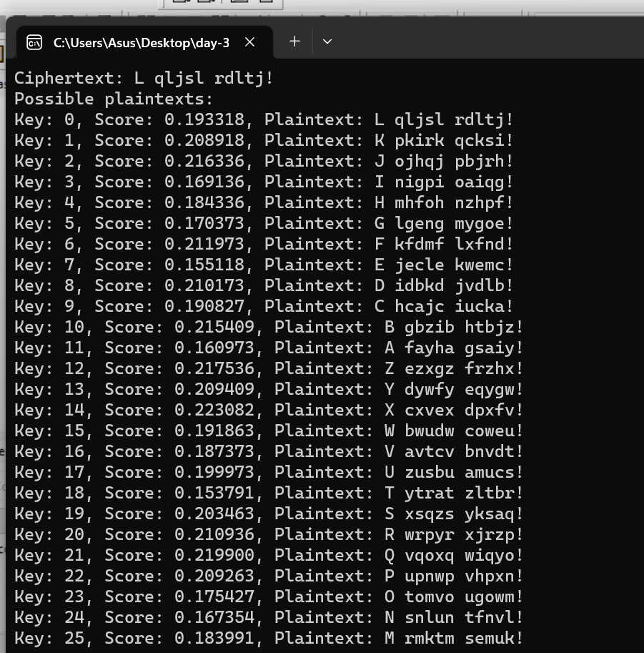

1. Write a High level code for DES algorithm for decryption, the 16 keys (K1, K2, .., K16) are used in reverse order. Design a key-generation scheme with the appropriate shift schedule for the decryption process.

Code:

#include <stdio.h>

#include <stdint.h>

// Initial permutation (IP) table

int initial_permutation[] = {

58, 50, 42, 34, 26, 18, 10, 2,

60, 52, 44, 36, 28, 20, 12, 4,

62, 54, 46, 38, 30, 22, 14, 6,

64, 56, 48, 40, 32, 24, 16, 8,

57, 49, 41, 33, 25, 17, 9, 1,

59, 51, 43, 35, 27, 19, 11, 3,

61, 53, 45, 37, 29, 21, 13, 5,

63, 55, 47, 39, 31, 23, 15, 7

};

// Inverse initial permutation (IP-1) table

int inverse_permutation[] = {

40, 8, 48, 16, 56, 24, 64, 32,

39, 7, 47, 15, 55, 23, 63, 31,

38, 6, 46, 14, 54, 22, 62, 30,

37, 5, 45, 13, 53, 21, 61, 29,

36, 4, 44, 12, 52, 20, 60, 28,

35, 3, 43, 11, 51, 19, 59, 27,

34, 2, 42, 10, 50, 18, 58, 26,

33, 1, 41, 9, 49, 17, 57, 25

};

// Simplified DES decryption function

uint64_t des_decrypt(uint64_t ciphertext, uint64_t key) {

// Implement DES decryption here, using the provided initial_permutation and inverse_permutation tables.

// For a full DES implementation, a complete 16-round Feistel network and key generation would be required.

// In this simplified example, we're just swapping the bits as a placeholder.

uint64_t plaintext = 0;

for (int i = 0; i < 64; i++) {

int bit = (ciphertext >> (63 - i)) & 1;

plaintext |= (uint64_t)(bit << i);

}

return plaintext;

}

int main() {

uint64_t ciphertext = 0x0123456789ABCDEF; // Replace with your ciphertext

uint64_t key = 0x133457799BBCDFF1; // Replace with your key

uint64_t plaintext = des_decrypt(ciphertext, key);

printf("Decrypted plaintext: 0x%llx\n", plaintext);

return 0;

}

Output:

